**2. Create a virtual machine with two operating systems, Windows 7 (or Windows 10) and Ubuntu 20.04 (in this order) and configure the bootloader to:**

**a. Set Windows as default entry and boot after 15 seconds if the user does not select another option in the menu.**

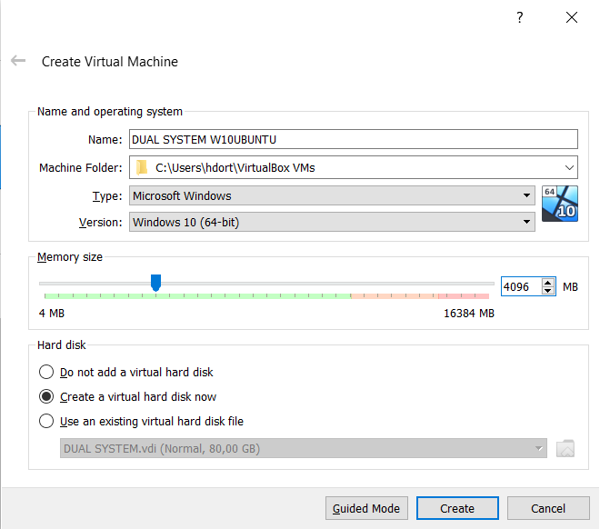

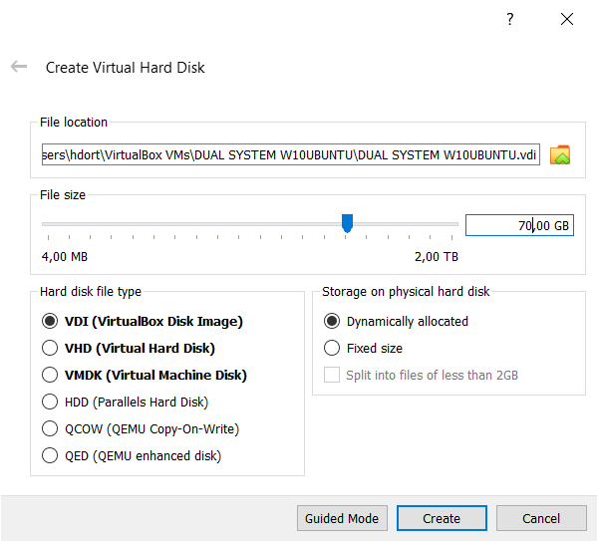

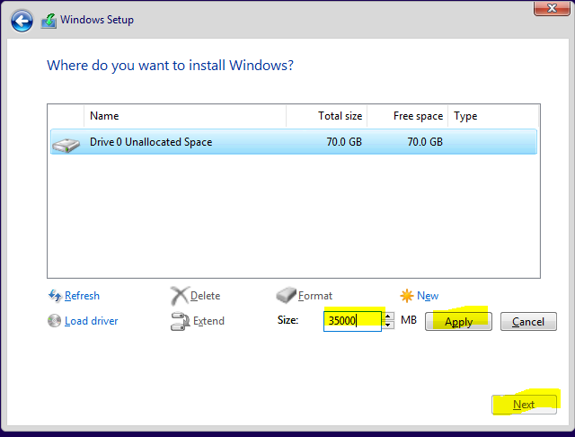

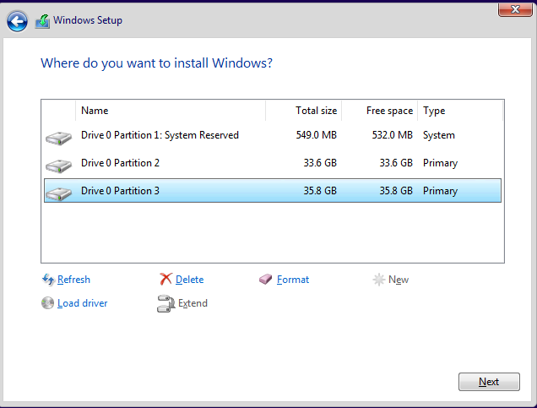

Ones we have Windows 10 installed, the next step is to install Ubuntu 20.04:

* In order to do this, we have to remove de virtual optical disk from the virtual drive and put Ubuntu iso file.

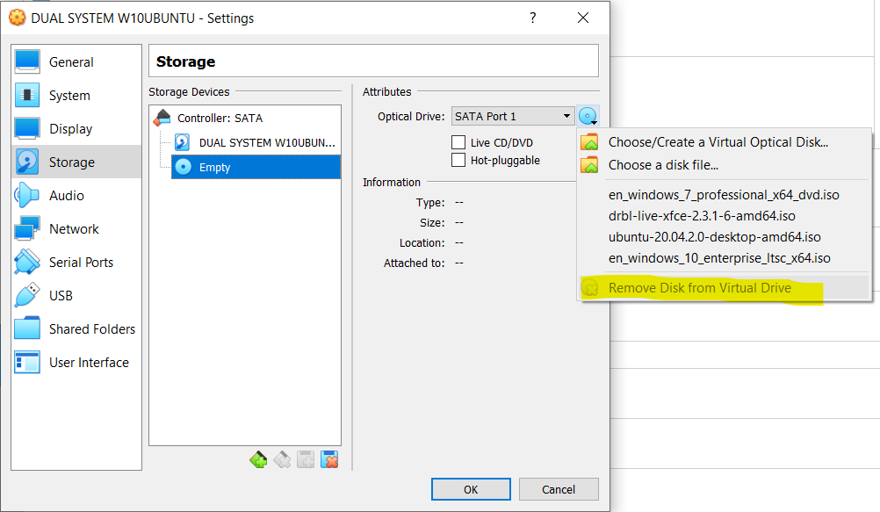

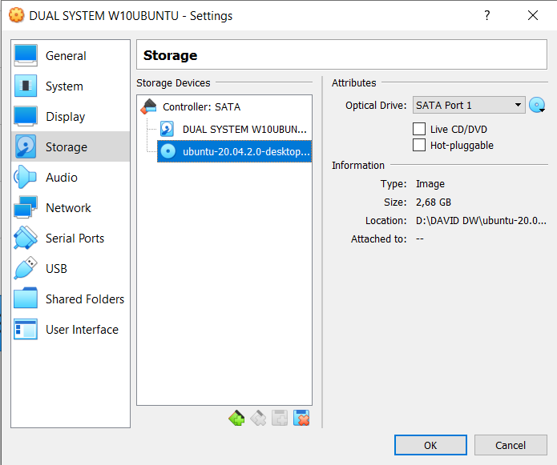

* Select the the correct keyboard, in order to do not have any compatibility problem.

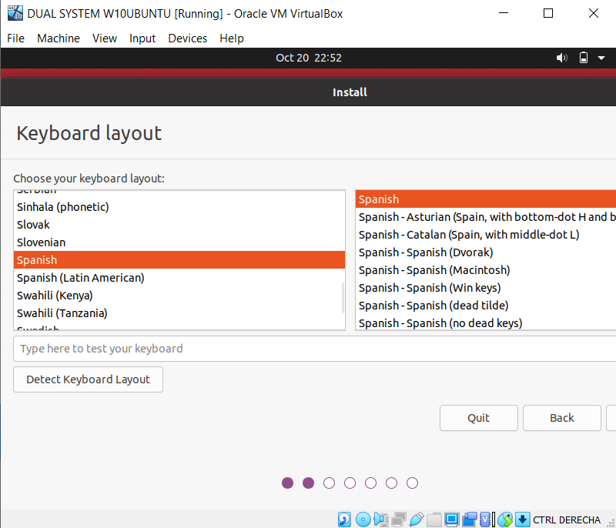

* Choose a normal installation.

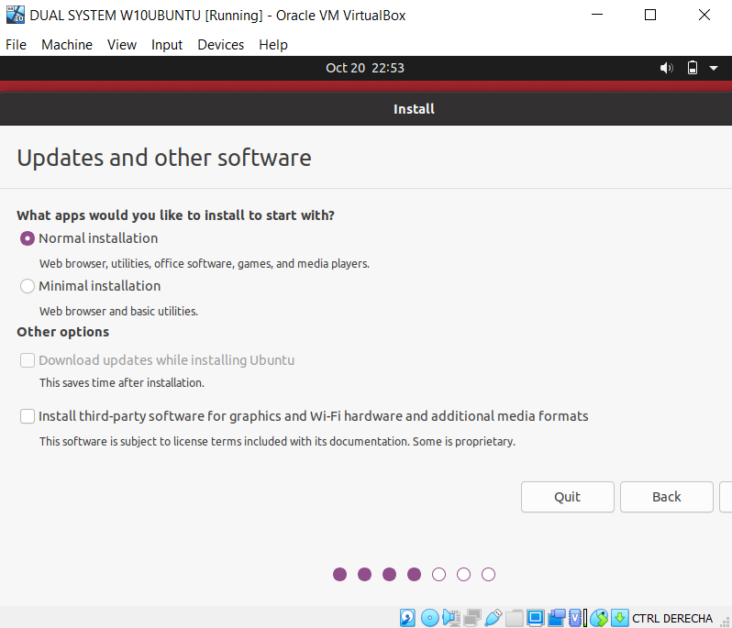

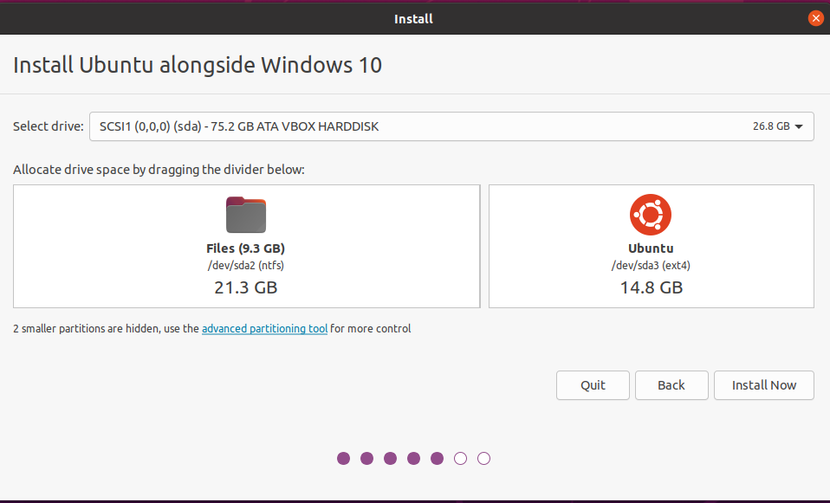

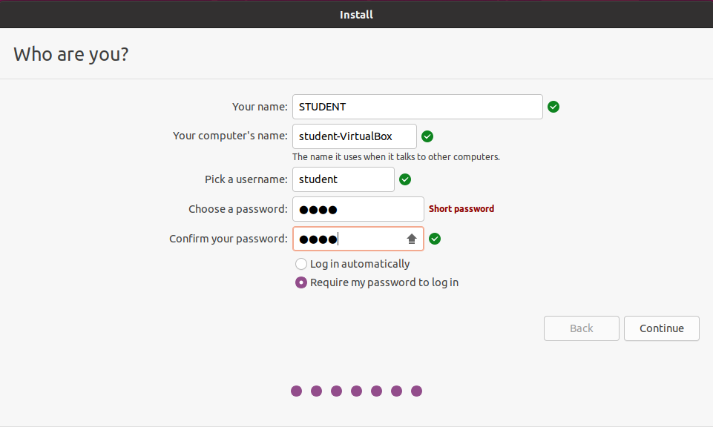

Now we have both opereting systems installed:

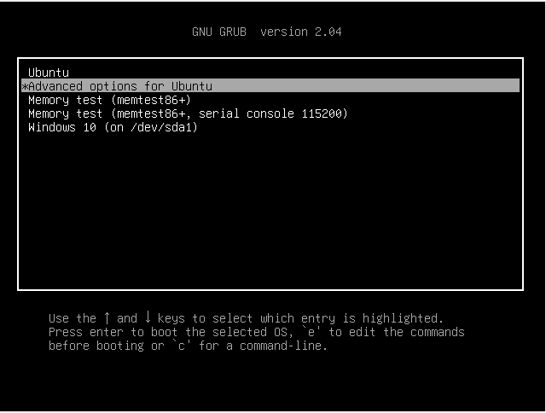

Ones we have our Ubuntu installed, we have to go to the terminal and do the changes like a administrator, to be able of this, we have to use the comand line sudo nano /etc/default/grub:

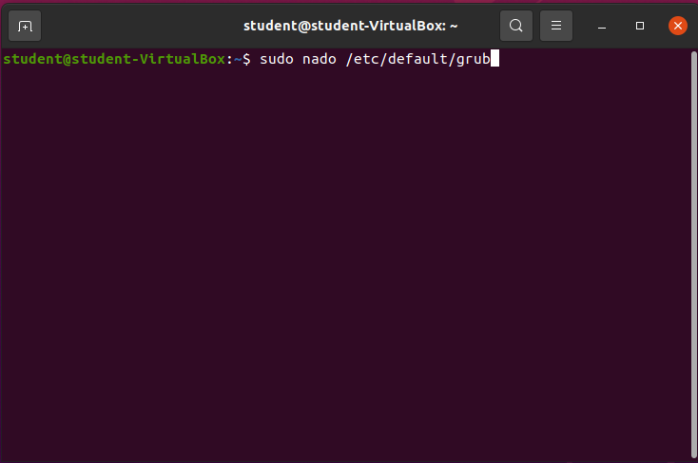

* Change the GRUB_DEFAULT to 4 because 4 is the potition of the Windows 10, and GRUB_TIMEOUT is the option that allow us to configure the countdown.

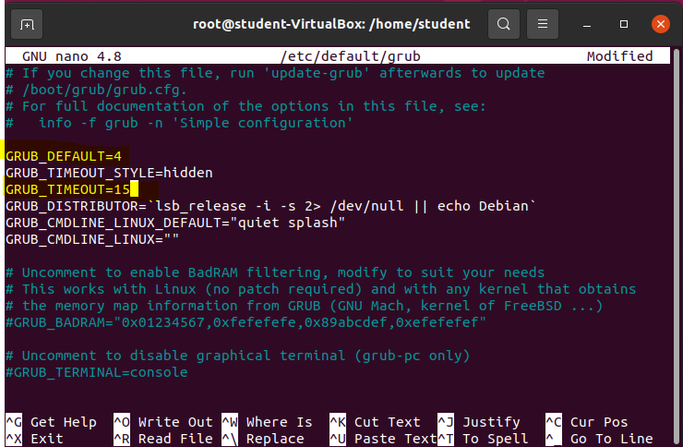

To finish this configuration we need have to exit and put the comand “update-grub2”

Now we can restart our virtual machine in order to confirm your configuration is made it:

